1 Introduction 1

3 Models in Simulation 1

3.1 Rydberg Atoms 2

3.1.1 Modern Model of Rydberg Atoms 3

3.1.2 Properties of Rydberg Atoms 5

3.2 Two-Body Model 6

3.2.1 What Is Two-Body Model 6

3.2.2 Nearest Neighbor Distribution 7

3.2.3 Förster Resonance Energy Transfer 8

3.3 Dipole-Dipole Interaction 8

3.3.1 Dipole Moment 8

3.3.2 Dipole-Dipole Interaction in Classic Picture 9

3.3.3 Dipole-Dipole Interaction in Quantum Picture 11

3.4 Blackbody Radiation Model 13

3.4.1 Blackbody Induced Transition 14

3.4.2 Radiation Model 14

Figure 3.1: Rydberg atoms of (a) H and (b) Na. In H the electron orbits around the point of charge of the proton. In Na it orbits around the +11 nuclear charge and ten inner shell electrons. In high l states Na behaves identically to H, but in low L states the Na electron penetrates and polarizes the inner shell electrons of the core [5]. 3

Figure 3.2: Schematic of pairs in MOT. For an atom in a MOT, we only consider the effect from its nearest neighbor. One atom and its nearest neighbor is considered to be “a pair of atoms”. 6

Figure 3.3: Schematic for typical FRETs. Black cycles represent the initial pair states and gray cycles the final pair states. (a) is , (b) and (c) [13]. 8

Figure 3.4: Schematic for interaction between two dipoles in classic picture. 11

Figure 3.5: Decay model for atoms starting from state 40*s* as an example. The red dash lines between two states mean there is blackbody stimulated transition between these two states. The blue dash curves mean the spontaneous decay. 15

# Introduction

# Models in Simulation

This chapter introduces general knowledge about the physical models used in the research. These models include Rydberg Atoms, Two-Body Model, Dipole-Dipole Interaction Model, Blackbody Radiation and etc. They are also expressed in math language so that they compose a mathematical background for the simulation implemented in Chapter 4, Chapter 5 and Chapter 6. Other than specifically mentioned, all the units in this chapter are atomic units.

## Rydberg Atoms

Back to 1885, Balmer found the wavelengths of the visible series of atomic H is given by [1]:

|  |  |  |
| --- | --- | --- |
|  |  | (3.1) |

where b = 3464.6 . We now know equation (3.1) is the formula for the wavelengths of the Balmer series of transitions from the n = 2 states to the higher lying levels.

After quantitatively describing the wavelengths from H, people started to work on other atoms to unravel the mystery of atomic spectroscopy. Living and Dewar found that the observed spectral lines of Na could be grouped into different series [2]. Hartley found the significance of describing Balmer’s formula in terms of the wavenumber of the observed lines instead of the wavelength during his reach on spectra of Mg, Zn, and Cd [3]:

|  |  |  |
| --- | --- | --- |
|  | . | (3.2) |

Now it’s more clear what Balmer discovered reflects the energy difference between the *n* = 2 states and the higher lying levels.

Following those precedents’ work, Rydberg began to classify the spectra of other atoms, notably alkali atoms, into sharp, principal, and diffuse series of lines [4]. He found the wavenumbers of lines connoting the *s* and p series, for example, are given by:

|  |  |  |
| --- | --- | --- |
|  |  | (3.3) |

where + sign and constant n describe a sharp series of *s* states and the minus sign and a constant m describe a principal series of *p* states. If and m = 2 we can get Balmer’s formula for the H transition from n = 2.

Due to his significant contribution, people are now naming atoms in states of high principal quantum number “Rydberg Atoms”.

### Modern Model of Rydberg Atoms

If we consider Rydberg states of H and Na, as shown in Figure 3.1, they are essentially similar. The only difference is that Na atom has a core which is composed of 11 positive charges and 10 electrons. For most of the time, the highest external electron (Rydberg electron) is far from the core and the difference between Na, H and all Rydberg atoms is minimal. But when the Rydberg electron comes near the core, it can both polarize and penetrate the core, and change the wavefunctions and energies of Na Rydberg state from their hydrongenic counterparts.



Figure 3.1: Rydberg atoms of (a) H and (b) Na. In H the electron orbits around the point of charge of the proton. In Na it orbits around the +11 nuclear charge and ten inner shell electrons. In high l states Na behaves identically to H, but in low L states the Na electron penetrates and polarizes the inner shell electrons of the core [5].

We know how to calculate wavefunctions of H [6]. This process can be easily extended to generate wavefunctions for single valence electron atoms with spherical ionic cores. Such an approach is called Quantum Defect Theory [7]. Quantum Defect Theory (QDT) assumes that the core is spherically symmetric and frozen in place. So the effective potential, seen by the valence electron is spherically symmetric and only depends on *r*. This potential is lower than the coulomb -1/*r* potential only at small *r*, and the effect is to increase electron kinetic energy and decrease the wavelength of the radial oscillations relative to H. Suppose the phase shift is . The bound state radial wavefunctions are given by:

|  |  |  |
| --- | --- | --- |
|  |  | (3.4) |

where and are commonly termed the regular and irregular coulomb functions. This radial function will derive the the allowed eigen energies:

|  |  |  |
| --- | --- | --- |
|  |  | (3.5) |

where n is an integer. Equation (3.5) is the equation used in the simulation to calculate the energies of Rydberg atoms. Table 3.1 gives the 0th order approximation of the quantum defect for Rb.

|  |  |  |  |  |  |
| --- | --- | --- | --- | --- | --- |
|  |  |  |  |  |  |
|  | 3.13109 | 2.65456 | 2.64145 | 1.347157 | 0.016312 |

Table 3.1:Quantum defects for low-ℓ states of Rb [5].

### Properties of Rydberg Atoms

Table 3.2 summarizes the properties dependent on principal quantum number n of Rydberg atoms [8].

|  |  |
| --- | --- |
| property | n dependences |
| Binding energy  Energy between adjacent n states  Orbital radius  Geometric cross section  Dipole moment <ns|er|np>  Polarizability  Radiative lifetime  Fine-structure interval |  |

Table 3.2: Properties of Rydberg Atoms.

As introduced in later sections, dipole-dipole interaction between Rydberg atoms is proportional to . And the Rydberg electrons are far from cores, which makes the them easy to be affect by external forces. The very long enough lifetime of Rydberg atoms also reduces the threshold of detecting development of atoms. All these superior properties make them ideal objects for researching dipole-dipole interaction and electron dynamics.

## Two-Body Model

### What Is Two-Body Model

When talking about Dipole-Dipole interaction (which will be introduced in detail in later sections) between atoms, a simplified two-body model is often used. In this model, we suppose one atom can only be affected by its nearest neighbor. Such an assumption is not very accurate of course, because a nearest neighbor could never block the influence from other atoms. But compared to many-body model, two-body model provides a concise way of thinking dipole-dipole interaction between atoms [5]. Besides, two-body effect has been accepted widely to be the major effect between atoms [9][10]. So in this dissertation, all the calculation and simulation is the based on the two-body model.



Figure 3.2: Schematic of pairs in MOT. For an atom in a MOT, we only consider the effect from its nearest neighbor. One atom and its nearest neighbor is considered to be “a pair of atoms”.

For a two-body model or a pair of atoms, we can write their state, in non-interacting basis, as the combination of their individual states. For example, for a pair of atoms which are in ns state and np state respectively, we can write the state of this pair as nsnp. We call this state “pair state”. Such a convention is followed in all sections of this dissertation.

### Nearest Neighbor Distribution

For a pair of atoms, to get the effect of one atom on the other, we need to find the distance between them. We use the so called “Nearest Neighbor Distribution” theory to find the distance between an atom and its nearest neighbor. The nearest neighbor distribution function H(r) for a D-dimensional system is described by [11][12]:

|  |  |  |
| --- | --- | --- |
|  |  | (3.6) |

where is the density of the atoms and is the volume of the D-dimensional sphere. For a 3-D system, we get the distribution function:

|  |  |  |
| --- | --- | --- |
|  | . | (3.7) |

From Equation (3.7), we can find the most possible distance between in one pair is:

|  |  |  |
| --- | --- | --- |
|  | . | (3.8) |

For a MOT with density , temperature about 100 K, the most possible distance between one atom and its nearest neighbor is about 5 m and the velocity of the atoms is of the order of 10 cm/s. In 1 s, one atom can move about 0.1 m which is much smaller than the distance between two atoms. So we could consider the atoms as “frozen” or static atoms in the MOT for our experiments.

### Förster Resonance Energy Transfer

Förster Resonance Energy Transfer (FRET) is a mechanism describing energy transfer between two atoms or molecules. It happens when two neighboring atoms are dipole-dipole coupled to higher and lower states with equal energy spacing. This mechanism could be described very easily using the two-body model (as shown in Figure 3.3). One atom is acting as a donor and the other one accepter. The atoms exchange energy as the donor is de-excited to a lower state and the accepter excited to a higher state. We utilize this mechanism a lot in our research described in this dissertation.

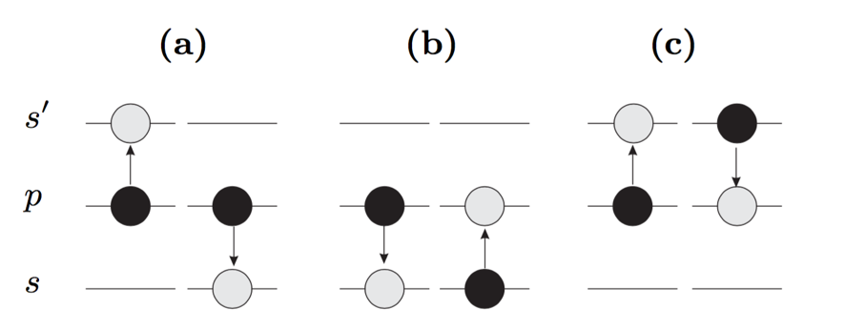

Figure 3.3: Schematic for typical FRETs. Black cycles represent the initial pair states and gray cycles the final pair states. (a) is , (b) and (c) [13].

## Dipole-Dipole Interaction

In the above discussion, dipole-dipole interaction has been mentioned several times. Now with the Rydberg Atoms model and two-body model, it makes easy to describe what exactly dipole-dipole interaction is.

### Dipole Moment

For Rydberg atoms, the most external electron spends most of the time far from the positive core. Although the atom as a whole is neutral, it has a polarity. We could simplify a Rydberg atom to be a system composed of a positive charge and a negative charge. Such a system is called a dipole and dipole moment is a measure of the polarity in this system. Its definition expressed in math is:

|  |  |  |
| --- | --- | --- |
|  |  | (3.9) |

where q is the charges’ amplitude and is the vector from the negative charge to the positive charge. This is a classic view of dipole moment and the dipole moment described in Equation (3.9) has a special name “permanent dipole moment”. This classic view will help us to understand the dipole-dipole interaction picture better. But another view from quantum physics is more commonly used.

In quantum physics, dipole moment is expressed as “transition dipole moment” and its definition is associated with the transition between state 1 and state 2:

|  |  |  |
| --- | --- | --- |
|  |  | (3.10) |

supposing charge is 1. Such a concept is introduced when calculating Schrodinger equation in quantum mechanics (see section 3.3.3). From Equation (3.10) we see if state 1 and state 2 are the same, then the transition dipole moment is 0, which means a transition dipole moment is always an off-diagonal matrix element.

This discussion about dipole moment has been divided into classic view and quantum view. Similar to that, dipole-dipole interaction model will also be explored from both views.

### Dipole-Dipole Interaction in Classic Picture

Although not very accurate, a classic dipole-dipole interaction picture has useful similarity to the interaction between quantum atoms and helps us to understand the quantum picture.

If there is only one dipole, the potential of this dipole is merely provided by the attractive force between the positive charge and negative charge. When two dipoles are getting close, the potential of such a system will be changed by the dipole-dipole interaction. As shown in Figure 3.4, two dipoles are interacting with each other. The total potential energy of this system does not only contain the inner coulomb potential of each individual dipole but also the potential caused by dipole-dipole interaction. The dipole-dipole interaction potential could be easily written as:

|  |  |  |
| --- | --- | --- |
|  |  | (3.11) |

From reference [14], Equation (3.11) could be simplified to:

|  |  |  |
| --- | --- | --- |
|  |  | (3.12) |

Expressed in dipole moments, Equation (3.12) could also be written as:

|  |  |  |
| --- | --- | --- |
|  |  | (3.13) |

where is the dipole moment of dipole 1 and is the dipole moment of dipole 2. From this expression, we see that whether the force between the two dipoles is attractive or repulsive is determined by the polarity of their dipole moments.

From Equation (3.13) we can also see the dipole-dipole interaction is strongly affected to the distance between the distance of dipoles or Rydberg atoms. This is the reason why two-body effect is the major effect in an ensemble of frozen atoms.

Suppose and q = 1, Equation (3.12) could also be written as:

|  |  |  |
| --- | --- | --- |
|  |  | (3.14) |

where , , and specify the position of the Rydberg electron in the ith atom relative to the center of the atom.

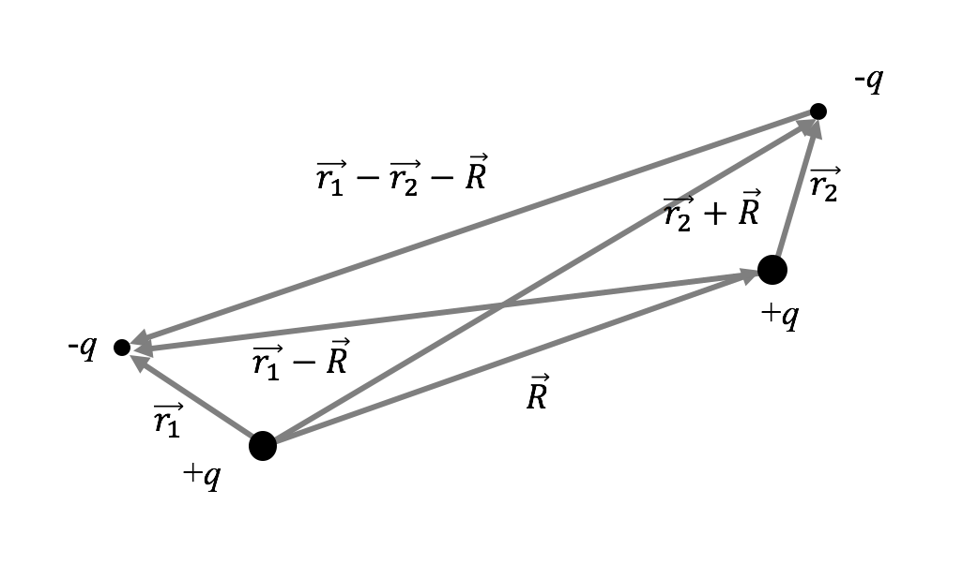

Figure .: Schematic for interaction between two dipoles in classic picture.

### Dipole-Dipole Interaction in Quantum Picture

The quantum dipole-dipole picture is based on the classic picture. Without loss of generality, we now continue with the resonance (a) in Figure 3.3. Suppose a system is composed of two dipoles starts from pair state *pp*, and we want to explore the evolution of the wavefunction in such a system. So we have:

|  |  |  |
| --- | --- | --- |
|  | . | (3.15) |

The total Hamiltonian of such a system is . *V* is the potential caused by dipole-dipole interaction as we discussion in the classic picture. The solution for time-dependent Schrodinger equation, is a combination of and :

|  |  |  |
| --- | --- | --- |
|  |  | (3.16) |

where all of the time dependence is contained in the coefficients and . And the Schrodinger equation can be written as:

|  |  |  |
| --- | --- | --- |
|  | ../../../../../Desktop/Screen%20Shot%202016-03-10%20at%202. | (3.17) |

where , with *p* and *q* representing pair states. And when in resonance . By solving Equation (3.14) we can get two eigen energy values:

|  |  |  |
| --- | --- | --- |
|  |  | (3.18) |

where *M* is expressed as:

|  |  |  |
| --- | --- | --- |
|  |  | (3.19) |

This expression utilizes the concept of transition dipole moment mentioned in section 3.3.1.

We can also get two eigen states from Equation (3.14):

|  |  |  |
| --- | --- | --- |
|  | . | (3.20) |

So the complete solution of the Equation (3.14) is:

|  |  |  |
| --- | --- | --- |
|  |  | (3.21) |

in which and are constants determined by the initial condition.

The above discussion gives us a simple example of dealing with dipole-dipole interactions in a two-state simple system. To calculate the matrix elements for such a system and more complicated system, we need to go to deeper details. By separating the radial part and the angular part, the calculation is implemented as follows.

From Equation (3.14), using the relations between the Cartesian coordinates and the spherical harmonics (

|  |  |  |
| --- | --- | --- |
|  |  | (3.15) |

the dipole-dipole interaction can be written in terms of spherical harmonics as:

|  |  |  |
| --- | --- | --- |
|  |  | (3.16) |

where is the spherical harmonics acting on the Rydberg electron of the *i*th atom.

To compute the matrix elements, Edmond’s C-tensors are introduced [15]. The relation between the spherical harmonic tensors and the C-tensors is:

|  |  |  |
| --- | --- | --- |
|  | . | (3.24) |

So the dipole-dipole interaction in form of C-tensors is:

|  |  |  |
| --- | --- | --- |
|  | . | (3.25) |

In Equation (3.25), a pair of C’s implies that the first C acts on the first atom and the second C on the second atoms.

Equation (3.25) is used in the simulation to calculation the matrix elements. As an example, the dipole-dipole matrix element between and is expressed as:

|  |  |  |
| --- | --- | --- |
|  |  | (3.26) |

where and are the radial matrix elements and the single state expression has a format of .

## Blackbody Radiation Model

Rydberg atoms are strongly affected by blackbody radiation, even at room temperature. The effect of thermal radiation is due two reasons [5]. First, the energy spacing between adjacent Rydberg levels are small (, so that at 300K. Second, the dipole matrix elements of transition between Rydberg states are large, providing coupling of the atoms to the thermal radiation. Because of the strong coupling between Rydberg atoms and the thermal radiation, population initially put into one state rapidly diffuse to other energetically nearby states by blackbody radiation.

### Blackbody Induced Transition

The spontaneous decay rate of the n state to the lower lying state is given by the Einstein A coefficient [16]. The thermal radiation induced stimulated emission rate is , which is the photon occupation number [17], times as large as the spontaneous rate:

|  |  |  |
| --- | --- | --- |
|  |  | (3.27) |

In terms of the average oscillator strength, Equation (3.27) is reexpressed as:

|  |  |  |
| --- | --- | --- |
|  |  | (3.28) |

where is the fine structure constant, is the energy difference , and

|  |  |  |
| --- | --- | --- |
|  |  | (3.29) |

where is the larger of and .

Equation (3.28) and Equation (3.29) are the equations used in Chapter 4 to calculate the blackbody radiation induced transition rate between nearby Rydberg levels.

### Radiation Model

When considering the decay of the population in one Rydberg state, as described in Chapter 4, radiation models similar to schematic in Figure 3.5 are used. There is blackbody induced transition between the starting state and its neighbors. There is also blackbody radiation between one neighbor and the neighbor’s neighbors. And so on. In calculation, a limited number of neighbors are chosen to make sure the calculation result converges.



Figure .: Decay model for atoms starting from state 40*s* as an example. The red dash lines between two states mean there is blackbody stimulated transition between these two states. The blue dash curves mean the spontaneous decay.

Bibliography

1. H. E. White, Introduction to Atomic Spectra, McGraw-Hill, New York (1934).
2. G. D. Living and J. Dewa, Proc, Roy, Soc. Lond, 29, 398 (1879).
3. W. N. Hartley, J. Chem. Soc. 43, 390 (1883).
4. J. R. Rydberg, Phil. Mag. 5th Ser. 29, 331 (1890).
5. Thomas F. Gallagher. Rydberg Atoms. Cambridge University Press (1994).
6. R. Shankar, Principles of Quantum Mechanics, 2nd Edition, Plenum Press (1994).
7. M. J. Seaton, Rep. Prog. Phys. 46, 167 (1983).
8. Thomas F. Gallagher. Rep. Prog. Phys. 51, 143 (1988).
9. B. Sun and F. Robicheaux, Spectral Linewidth Broadening from Pair Fluctuations in A Frozen Rydberg Gas, Phys. Rev. A. 78, 040701 (2008).
10. I. Mourachko, D. Comparat, F. de Tomasi, A. Fioretti, P. Nosbaum, V. M. Akulin, and P. Pillet, Many-Body Effects in a Frozen Rydberg Gas, Phys. Rev. Lett. 80, 253 (1998).
11. S Torquato, B Lu and J Rubinstein, Nearest-neighbour Distribution Function for Systems of Interacting Particles, J. Phys. A: Math. Gen. 23 (1990)
12. Hertz P, Math. Ann. 67 387 (1909).
13. S. Westermann, T. Amthor, A.L. de Oliveira, J. Deiglmayr, M. Reetz-Lamour, and M. Weidemuller, Dynamics of resonant energy transfer in a cold Rydberg gas, Eur. Phys. J. D 40, 37–43 (2006).
14. F. Robicheaux, J. V. Hernández, T. Topçu,1 and L. D. Noordam, Simulation of Coherent Interactions between Rydberg Atoms, Phys. Rev. A. 70, 042703 (2004).
15. A. R. Edmonds, Angular Momentum in Quantum Mechanics, Princeton University Press, Princeton (1960).
16. H. A. Bethe and E. A. Salpeter, Quantum Mechanics of One-and-Two-Electron Atoms, Academic Press, New York (1957).
17. R. Loudon, The quantum Theory of Light, Oxford University Press, London (1973).